Name: Arafat Islam
ID: IT-17008
Lab No 05
Lab Name: Connecting a database (MySQL) with Linux
Objectives:
From this lab,we learnt about how to
i) Install MySQL on Ubuntu
ii) Log into MySQL by Linux.
iii) Create database table.
iv) Insert data into table.
v) Describe table.
vi) Alter table.
vii) Modify table.
viii) Drop data from table.
ix) Update data of table.
x) Where and delete operation.
Connecting a database (MySQL) with linux

1. Install MySQL on Ubuntu .

sudo apt-get update
sudo apt-get install mysql-server
mysql_secure_installation
2. Log into mysql by linux ubuntu.

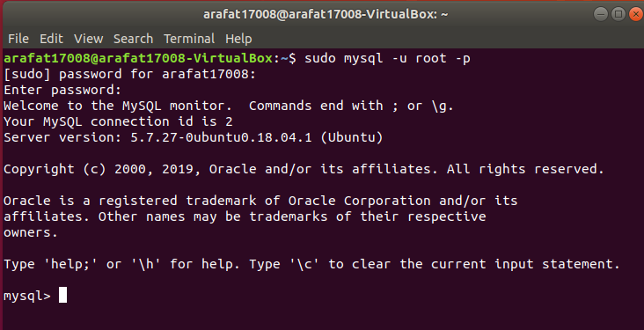

3. show and create database :

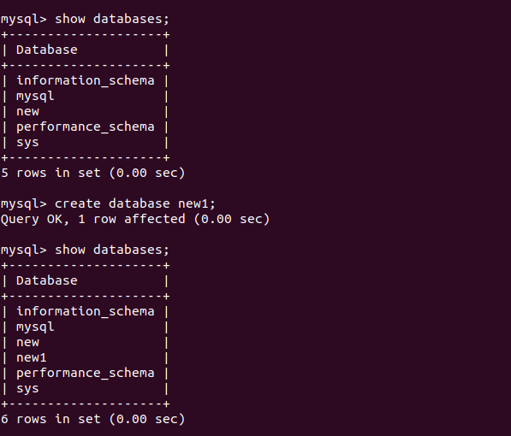

4. show and create table :
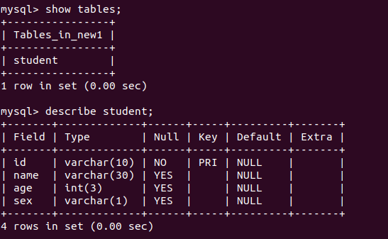

5. insert data into table :
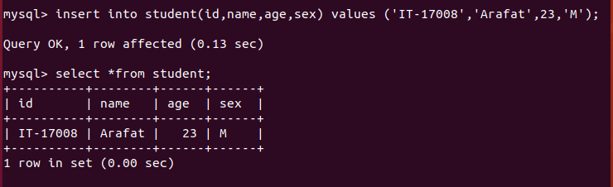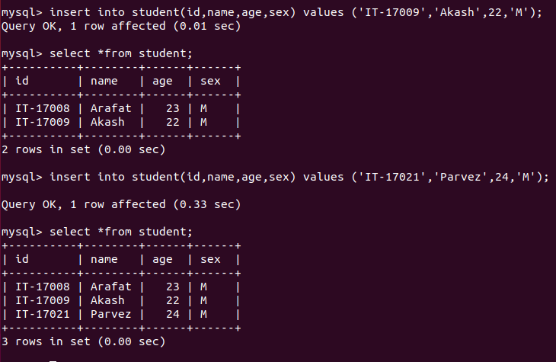
6. Describe table:
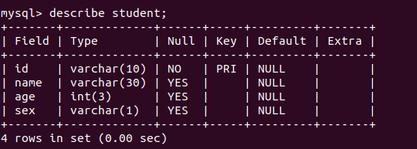

7. alter table :
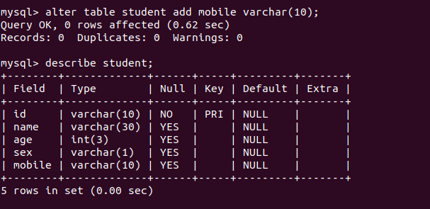
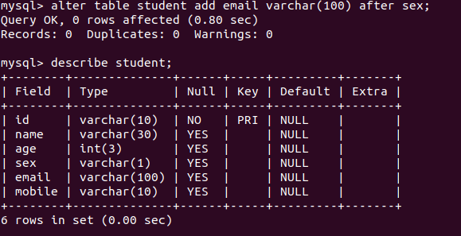

8.modify table:

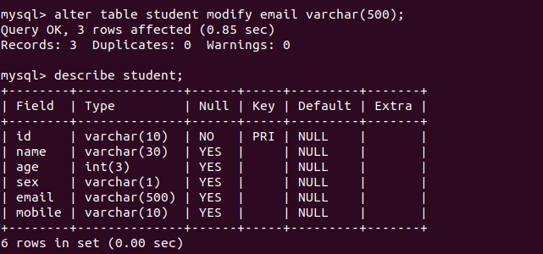

9. drop data from table:

